Lesson Plan
Grade Level: 8th-grade
Topic: Transformations (Translation)
Big Mathematical Ideas: Learning and discovering properties of translation.
Key Terms or Vocabulary: Translation, Image, Direction, Distance
Objectives:
M.8.3.2.1. Draws the images of points, line segments, and other shapes resulting from translation.
M.8.3.2.3. It creates the image of polygons resulting from translation and reflection.
Prerequisite Knowledge and Skills:
M.3.2.4.1. Recognizes the point, shows it with symbols and names it.
M.3.2.4.3. Creates line segments with line models; Makes drawings of horizontal, vertical and inclined line segment models by giving examples.
M.5.2.1.1. Explain line, line segment, ray and show with symbol.
M.5.2.2.1. Names and creates polygons and recognizes their basic elements.
Duration: 40 minutes
Materials: Geogebra files, Geogebra application, activity sheet, video
Links:
Video: https://www.youtube.com/watch?v=njp6yexWbfw

Opening (12 min): The lesson begins by asking ‘’Is there anybody who knows M. C. Escher?’’ and after students’ responses. Escher is introduced to the students and the video about the works of Escher is watched ( one minute of the video will be enough). Then ask the students ‘’ What do you see in his works, is there a common point?’’ after the students’ answers, it said that his works are examples of tessellations and Escher combined mathematics and arts. Also, it mentioned that Escher used transformations to create these works and one of the transformations that he used was a translation, after ‘’students are asked what is translation and what is needed for translation, and from students’ answer a summary is made and explained that translation requires a direction and a distance, in a translation, every point on the preimage moves in the same direction for the same distance to form the image. Then an example from his works is given and explained how he used translation.
Example:

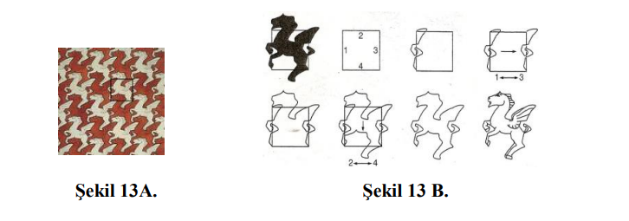

After this example, activity is introduced. For the activity, students use Geogebra application.
Activity:
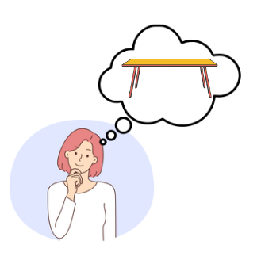

Selin wants to sew a tablecloth for the dining table. She couldn't decide what kind of tessellation to decorate the tablecloth with.

Can you create a tessellation for her tablecloth?

- By using translation create a tessellation on GeoGebra.

- Can you draw part of your tessellation on the given grid paper?


- Describe the direction and distance in your translations.

Firstly, students are asked what the task is about. Then the teacher wants students to open their GeoGebra application and tells them they create a tessellation using translation like Escher did.

Middle (20 min): Students work individually because every student creates on their tessellation and they work on a computer. In the first part of the task, students work on GeoGebra with their teacher. Procedures are applied step by step with teacher guidance in Geogebra. In each step, the teacher explains what to do and shows the steps on Geogebra. For instance, in step 2 teacher says that using one side of a parallelogram line segments are created then in step 3 a vector is formed and line segments are translated by vectors. At this point, the teacher explains a vector is used since vectors have length and direction, and in the translation direction and distance are required hence vectors meet these needs. In the steps, some questions can be asked, in steps 3 and 4, ‘’How many units were the points translated? and How can you find it?’’ and in step 5, ‘’ How the polygon is translated, Can you explain it, and Does the size of the polygon change when you translate ?’’

In the second part, students draw the part of their tessellations so that they can show and realize how translation can be done. Students are observed and some questions can be asked such as ‘’how do you translate your points, what is your direction and distance in translation for this point and can you explain and show it?’’
In the third part, students write the distance and direction when they apply translations. This allows them to look at and check their drawings.

Since every student has different tessellations after the task is completed randomly selected students show their tessellations to the classroom and students discuss what shape they formed and how they applied translation.

Expected Students Answer:
Every student has a different tessellation and given below can be one of them.
For first part:
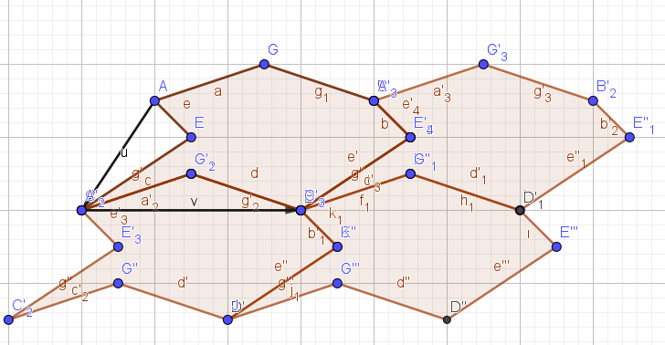

Second part:
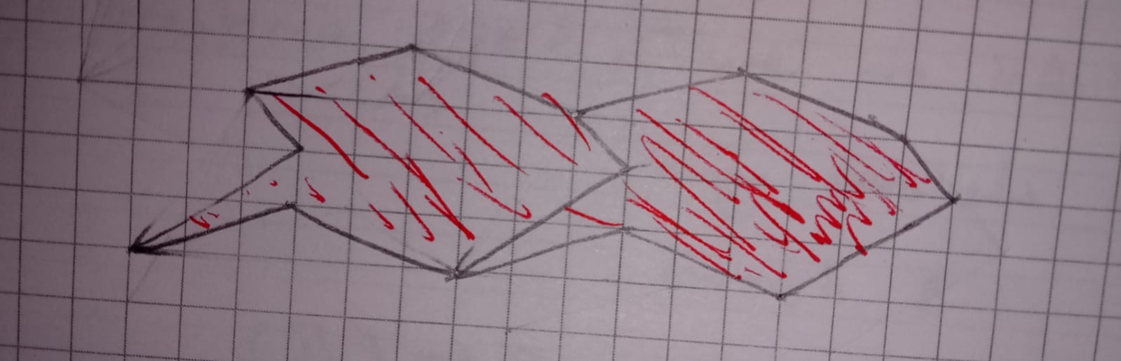

Third part:
A student can say that every point on polygon translated 6 units to the right while the polygon is translated. Also, he/she says that while a polygon is formed line segments of one side are translated 6 units right and the line segments of the other side are translated 2 units left and 3 units below.

Students Misconceptions
- Students do not pay attention to the distance and translate every point using different distances.

To overcome this, students are asked to compare the shape and the translated shape and the teacher asks them whether these two shapes are the same, also it is remembered that in translation direction and distance are required and all points on the shape are translated in the same distances. Then, it is asked students to translate the shape according to this information.
Difficulties that students can have
- Students can have difficulty following the teacher during the activity.

To overcome this, a teacher makes sure that everyone follows him/her and controls whether students are at the same step, and after each step, it can be asked ‘’did you apply this step or is there anybody who has a problem?’’ and the teacher can wait a little before passing next step.

- Students can have difficulty using GeoGebra tools

To overcome this, in each step, a teacher can show what to do in detail and how to use and access that tool. For example, in step 1, to form a parallelogram, firstly a line is created by using the line button which is on the left corner, and at the same time it is shown on the board by the teacher.

Closing (8 min): Students are asked what they learned today. After the students’ answer, the teacher makes a summary by saying ‘’today it is talked about Escher and how he uses mathematics in his works, then on Geogebra different tessellations are formed by using translation.’’ Lastly, the teacher asks to students ‘’do you have any questions’’ and then passes the assessment part and gives them exit cards. For exit cards, approximately 2 minutes will be enough.

Assessment:
Translate the shape 2 units right and 5 units below. Translate the shape 3 units right and 4 units below.
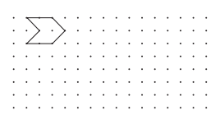


Translate the shape 4 units left and 4 units above. Translate the shape 5 units left and 3 units above.
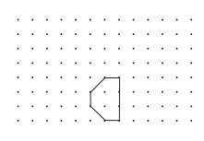


There are four different exit cards. According to the number of students in the class, some of the students get the same exit card. For instance, if the class consists of 20 students, every five students get the same exit card.

